

College of Letters & Science

Teaching Assistant Training & Orientation

Fall 2021

# Table of Contents

**Welcome to L&S and the Fall 2021 Semester!** **2**

**Canvas Hub** **3**

**Agenda: September 2, 2021** **3**

**Introduction to the College of Letters & Science** **4**

**UHS: TA Wellness & Stress Management** **5**

**Panel: Putting Wellness into Practice** **6**

**Small Group Session: Student-Centered Learning** **7**

**Small Group Session: Active Learning & Backward Design** **9**

**Small Group Session: Difficult Classroom Situations** **18**

# 

# Welcome to L&S and the Fall 2021 Semester!

Dear Teaching Assistants,

Welcome to the Fall 2021 L&S TA Training event! For those of you new to this role, congratulations, and welcome to the University of Wisconsin-Madison teaching community! We are thrilled you are here, and we hope to help you start teaching with confidence. To the returning TAs, welcome back! Our aim is to provide many opportunities for you to further hone your teaching skills.

We hope you are excited about being a TA, but we understand that you might also feel nervous, concerned, or a whole host of other things. We particularly recognize that teaching during the COVID19 pandemic may present unique challenges. We also recognize that while you are a TA, you are also a student, a scholar, and a person, which means you have a wide range of responsibilities to juggle. Our goals include providing you with numerous resources to help navigate the coming semester, and creating a supportive community of TAs that you will be able to lean on.

Undergraduate education is central to the mission of the College, and you all play an integral part in carrying out that mission. We know that poor teaching disproportionately affects underserved student populations, such as students of color and first-generation college students, leading to disproportionately high dropout rates. As a TA you are on the frontline of teaching, which gives you a valuable opportunity to help address this problem. By following best practices and teaching inclusively, you can help ensure that all students, regardless of their background, have the chance to succeed. The College is fully invested in helping each of you achieve this goal. We hope that today’s training, as well as a number of follow-up resources, empower you to teach in such a way that you and all your students will learn and succeed.

Today’s training is just the beginning! Teaching is a constant process of improvement. It requires staying current with best practices and trying (and re-trying and probably re-re-trying) different methods and activities. You will start this journey today, and it will continue throughout your time at UW. We will provide information on a number of follow-up resources and trainings, and please watch for future workshops and other opportunities to continue improving as a teacher.

We wish you the best of luck and happiness as you start teaching. It truly can be a deeply rewarding and impactful experience.

Cheers,

The L&S Team

# Canvas Hub

Fall 2021 L&S TA Training on Canvas: <http://go.wisc.edu/p13d2s>

All communication about our Fall 2021 L&S TA Training will happen through Canvas. We will also use Canvas to send updates and additional information after the September 2 event, including recordings of our large group events.

# Agenda: September 2, 2021

*All times are listed in Central Time.*

|  |  |  |  |
| --- | --- | --- | --- |
| **Start Time** | **End Time** | **Topic** | **Presenter(s)** |
| 8:30am | 9:00am | Meet your Group & Teaching Fellow | Teaching Fellows |
| Short Break | | | |
| 9:05am | 9:35am | Welcome to the College of Letters & Science | Lynne Prost, L&S Assistant Dean for Graduate Student Academic Affairs |
| Short Break | | | |
| 9:45am | 10:45am | TA Wellness & Stress Management | University Health Services |
| Short Break | | | |
| 11:00am | 11:45am | Panel: Putting Wellness into Practice | Teaching Fellows |
| 11:45am | 12:45am | Lunch Break |  |
| 12:45pm | 1:15pm | Student-Centered Learning | Teaching Fellows |
| Short Break | | | |
| 1:25pm | 2:30pm | Active Learning & Backward Design | Teaching Fellows |
| Short Break | | | |
| 2:45pm | 4:00pm | Difficult Classroom SItuations | Teaching Fellows |

# Introduction to the College of Letters & Science

9:05am - 9:35am CDT (2/7)

## Presenters

|  |  |
| --- | --- |
| Dani Clevenger [she/her]  L&S Teaching & Learning Administration  [teachingandlearningpa@ls.wisc.edu](mailto:teachingandlearningpa@ls.wisc.edu) | Lynne Prost [she/her]  Assistant Dean for Graduate Student Academic Affairs  [lprost@wisc.edu](mailto:lprost@wisc.edu) |

## Essential Resources

L&S Administrators:

* Dean Eric Wilcots: Chief academic and executive officer of L&S
* Associate Dean Shirin Malekpour: Leads L&S teaching and learning initiatives and activities
* HR Manager Laura Fisk: Handles hiring, pay, benefits, and other issues related to employment of graduate assistants (including TAs)

Up-to-date COVID information:

* Campus COVID-19 response: <https://covidresponse.wisc.edu>
* Fall 2021 instruction: <https://teachlearn.provost.wisc.edu/fall-2021-instruction/>

## Reflection

Think of the best teacher you’ve had. What words or phrases describe them?

|  |
| --- |
|  |

## Continued Support for TAs

* Center for Teaching, Learning, and Mentoring workshops: <https://ctlm.wisc.edu/events/>
* DELTA Workshops: <https://delta.wisc.edu/events/>
* Office Hours with a Teaching Fellow (next week)
* Email teachingandlearningpa@ls.wisc.edu

# 

# UHS: TA Wellness & Stress Management

9:45am - 10:45am CDT (3/7)

## Presenters

Our guest presenters from University Healthy Services (UHS) are mental health practitioners and will provide an overview of stress with strategies and tips for managing stress.

|  |  |
| --- | --- |
| Liz Wescott Barten, LPC [she/her]  Access Specialist, Care Manager, Group Facilitator | Denise Calhoun PhD [she/her]  Associate Psychologist , Group Facilitator |

## Essential resources

* University Health Services - Mental Health: <https://www.uhs.wisc.edu/mental-health/>
* UHS 24/7 Crisis Line: 608-265-5600, option 9
* National Crisis Text Line: Text “HOME” to 741741
* [Email template](https://docs.google.com/document/d/1yGmELaPSSJC3yo5q_kzvjdQh29ajR98ZJSzPt-XCMFw/edit) for communication with students of concern. Worried about a student but unsure what to say? Use these email templates to help you reach out.

## Notes

# 

# Panel: Putting Wellness into Practice

11:00am - 11:45am CDT (4/7)

Following our presentation from UHS, a few of our L&S Teaching Fellows will share some unexpected teaching challenges they have experienced while TAing. They will also discuss how they navigated these challenges with a focus on strategies and resources that have helped them maintain their wellbeing.

## Notes

# 

# Small Group Session: Student-Centered Learning

12:45pm - 1:15pm CDT (5/7)

## Learning Outcomes:

* TAs will explore with their peers ways to create a supportive classroom space.
* TAs will identify some common mistakes that come from being too focused on the experience of the teacher (themselves) and how to productively reframe their role in the classroom.

You and your breakout group will be in charge of analyzing one of the following journal entries (your Fellow will tell you which one). You will then report on your analysis to your cohort. Focus on questions like: What problems do you see in the entry? What could the TA have done to avoid the problems in the first place? What should the TA do going forward?

## Teaching Journal Entries Notes

**Sept 9th:** So, today was my first day teaching! I think it went pretty well. I did my favorite icebreaker activity where everyone has to say their favorite character from Walking Dead (a.k.a the best show ever). Not everybody had one, but it was pretty funny and I think it made me more relatable, so my students can connect to me. I made sure to stick to my lecture notes that I planned out before section, but the students kinda started to get off track, which was frustrating. I also was able to answer every question they had so I don’t seem like an idiot or anything. This is going to be great– I’m secretly hoping that I can get them to want to switch majors.

**Oct 19th:** I didn’t know teaching could be so nerve wracking. Every eye is on me and I’m expected to know the answers to everything. The good news is I prepare really well just like Dr. Professor. I write down these really detailed lectures to read to the students so that I can cover all of the information and nuances. I also make sure to walk through exactly how I do the problems on the board so they know how to do them.

**Nov 2nd:** Alright, so I kinda thought class participation would be better by now because everyone has had more time to get to know each other. I mean, I’ve talked to basically all them and I know their names, but getting them to volunteer questions or anything is like pulling teeth. Right now the same three students talk all the time. Which, I mean, isn’t that bad because they’re really bright and motivated so they’re fun to talk to, and the other students are listening, so they should be picking it up. I guess if they don’t participate that’s their problem.

**Dec 5th:** Thanksgiving break is over, and now we have to pack in a lot before the end of the semester. Still not a lot of participation, so this week I thought I’d try preparing questions about the material that are super interesting to see if that would get them going, but they still just sat there and stared at me. I basically ended up answering all of the questions. I don’t get it. The readings are super interesting and I think they’re just being lazy or aren’t smart enough to get what we’re doing. I think only one or two of them (the usual suspects) actually listen when I talk about the material. They say they’re spending hours going over this stuff, but I think if they all actually put in the work they’re saying they’d be able to do the problems and stuff. Argh.

# Small Group Session: Active Learning & Backward Design

1:25pm - 2:30pm CDT (6/7)

## Learning Outcomes:

* TAs will be able to explain the following concepts: active learning, backward design, learning outcomes, assessment, and learning activities.
* TAs will experience active learning and reflect on its benefits.
* TAs will practice using backward design to create a first section plan.

## Reflection

Think about a time when you learned something really significant, complex, or difficult. It doesn’t have to be an academic topic or concept. Write in the space below how you learned this new thing.

|  |
| --- |
|  |

After completing your reflection, you will pair up and discuss with a partner. Use the space below to note any commonalities and common themes in how you each learned something difficult.

|  |
| --- |
|  |

## Active Learning Takeaways

Here’s a secret we don’t often tell students—lecturing is a pretty ineffective way to learn. We know this from a robust body of empirical experiments on teaching and learning. For instance, we know that student attention begins to decline after 10-15 minutes of lecture, and, after 10 minutes, retention of content drops considerably. So, if you’re interested in students truly knowing what you want to teach them, you have to approach teaching differently.

One of the best ways to do this is to start looking at learning from a **student-centered** perspective. Student-centered approaches to teaching flip the traditional dynamics of the classroom, and they emphasize learner autonomy and individuality over conformity and passivity. Traditionally, the teacher is seen as the primary source of knowledge. At the level of higher education, they can attain almost god-like status, making it seem like only they can have anything worth saying or contributing to the classroom. The student-centered approach to teaching dislodges this narrative and puts the students at the center of the learning process.

Once the teacher is no longer seen as a “sage on stage” the classroom becomes a place suited for **active learning**. In active learning, the focus is what the students need to do in order to learn. It’s normally conceptualized as, “instructional activities involving students in doing things and thinking about what they are doing.” They can no longer sit passively and merely listen, but must engage in the process of their own education. Active learning allows and expects the students to be vital participants in both the teaching and learning happening in the classroom. The core question of active learning is: what things should my students do, and in what order, to help them move from where they are towards my learning outcomes?

Some nice examples of active learning activities can be seen in the document located here: <https://blendedtoolkit.wisc.edu/deliver/activelearning/>

## Reflection

Consider what you wrote above, about how you learned something difficult. In what ways was your learning process student-centered and active?

|  |
| --- |
|  |

## Backward Design Basics

One of your regular tasks as a TA will be to plan sections. This can sometimes be daunting—figuring out what to do with a whole bunch of students that will help them learn and be worth their time can be overwhelming. New teachers regularly have the fear of students just sitting there staring blankly back at them while crickets chirp in the background. Luckily, there is a proven method to help plan sections called **Backward Design**. This method, as its name suggests, has you start by thinking backwards. You begin by answering the question: how do you want students to be different by the end of their time with you?

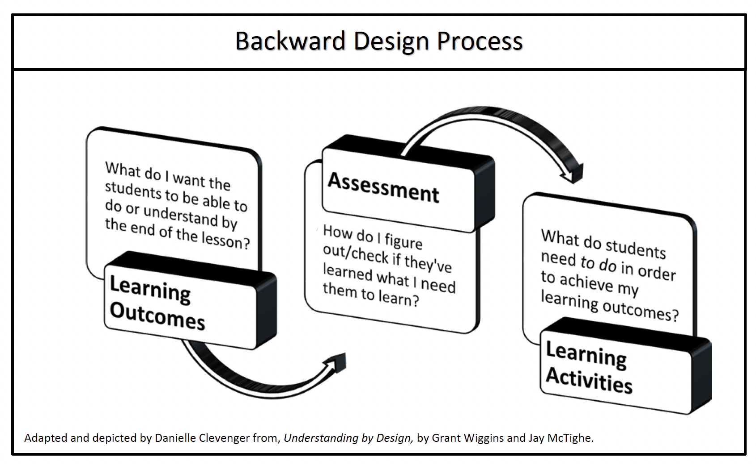

You want to treat section planning (or any other learning planning) like you are making a map through uncharted territory for your students. In order to make this map, the first thing you need to know is where they should be going. There is little use in having everyone wander around random paths and end up at different places—places you might not even want them to go. This means you should start by identifying for yourself, and for them, where they are going.

### Learning Outcomes

This step of identifying where you want students to end up is done by selecting your **learning outcomes**. Learning outcomes are what the students should be able to do by the end of the lesson. They should start with verbs, so the students understand what they are supposed to be able to do in the future. The more concrete and specific the verbs are the better! Creating learning outcomes this way helps ensure both you, and your students, are clear on where they’re going. Don’t be afraid to think of verbs beyond the standard: read, think about, discuss, write, etc.

|  |  |
| --- | --- |
| **Learning Outcomes:** Take a moment to think about what learning outcomes would be appropriate for your first section. You can jot down your ideas on the other side of this chart.    For any given lesson you should only have one or two learning outcomes. Remember they should start with a concrete verb and be specific.    Examples:  1. Students should be able to identify the main elements of deductive and inductive arguments.    2. Students should be able to perform a two- tailed T-Test using statistical analysis software.    3. Students should be able to use active reading strategies to help break down complicated texts. | *Possible Learning Outcomes:*                    *Final Learning Outcome(s):*  1.      2.      3. |

### Assessment

Once you’ve identified where the students need to go, the next step is to figure out how you will know if they have actually gotten there. What is something the students could do to show you they have reached your outcomes? This is where **assessment** comes into play. Assessments are designed to help you, and your students, know if they have gotten to where you wanted them to end up.

Below is a list of some assessment strategies starting from low-involvement and ending with higher involvement. After taking a moment to look through these, determine and highlight/note which ones are particularly apt for the type of teaching you are doing. Star at least one assessment activity you could use during your first section to help you determine where your students are at.

|  |  |  |
| --- | --- | --- |
| **Assessment Name** | **Brief Description** | **Example** |
| 1. One to Five | In order to get a quick idea of how well students are following a major point in a lesson, ask them to hold up one to five fingers, where the numbers correlate to how well they are following a concept. | For example, for any given question the instructor can ask the students to hold up fingers where one stands for “completely lost” and five stands for “I could teach this myself.”    This can also be easily used to gauge interest levels and confidence levels. |
| 2. Focused Listing | Ask students to briefly list and possibly even define key terms or ideas related to an important point of the day’s lesson. | For example, a physics teacher might ask students to list five words or phrases related to the term work in physics. She then collects them to determine if the students are correctly conceptualizing ‘work’ in physics as opposed to ‘work’ in everyday vocabulary. |
| 3. Pros and Cons | Have students develop brief lists of pros and cons in relation to a particular question or stance. | For example, an ethics teacher might ask students to list three pros and three cons of using CRISPER to edit the genes of an embryo. |
| 4. Background Knowledge Probe | Create three questions. The first should be a very easy question related to your topic. The second should be somewhat difficult, and the third should be quite difficult.    Once the students have attempted the problems, the teacher can then use the responses to determine how much background knowledge her students have on the topic. | For example:  1. What is a Punnett square?  2. What is the purpose of recombination?  3. Explain how scientists determine what gene(s) are responsible for specific phenotypic traits. |
| 5. Process Analysis | Have students write down each step they perform as they do some common activity, such as a lab report, literary analysis, or proof. Have students reflect on their own process and how effective it was in doing the highlighted activity. Have students share and brainstorm ways to do the activity better next time. | For example, have students write down all the steps they take in learning to play a complex piano piece. Each step need not be more than a sentence or two. The students analyzed the different processes to find ways they could improve how they prepared and practiced to perform the piece. |
| 6. Exam or Paper Wrappers | Following a difficult exam or paper, instructors should create a sheet that has structured reflection questions. The questions should help the students frame the mistakes they made, and help them learn how to do them correctly. | For example, questions for a test could include:  1. What types of questions did you do well on? Why do you think you did well on them?  2. Where did you go wrong in answering this question? What should you do differently the next time you see a problem like this one.  3. What would you do differently to prepare for a test like this in the future? |

### Learning Activities

Finally, the last part of Backward Design asks you to figure out *what the students need to do to get from wherever they currently are to where you want them to be*. This will be your **learning activity**. At this point, your job is to help them take steps in the right direction in order to get them from Point A to Point B.

Imagine you are in a spy movie, one of those high-tech, action packed ones. In those movies the spy infiltrating some top-secret place almost always has a friend looking at a map of the building telling them where to go and what to do. When you are teaching, you are the friend with the map, helping the spy—your student—to get to wherever they need to be.

It’s during this stage of the planning your expertise really comes into play. You have to determine the best path, which should be a bit easier for you because you have done it before. You can also highlight common mistakes to avoid—like pits full of quicksand or trap doors. Overall, the best thing you can do for your students (or your spies) is to keep constantly communicating with them and assessing where they are. This ensures that you can always change your directions if they aren’t working.

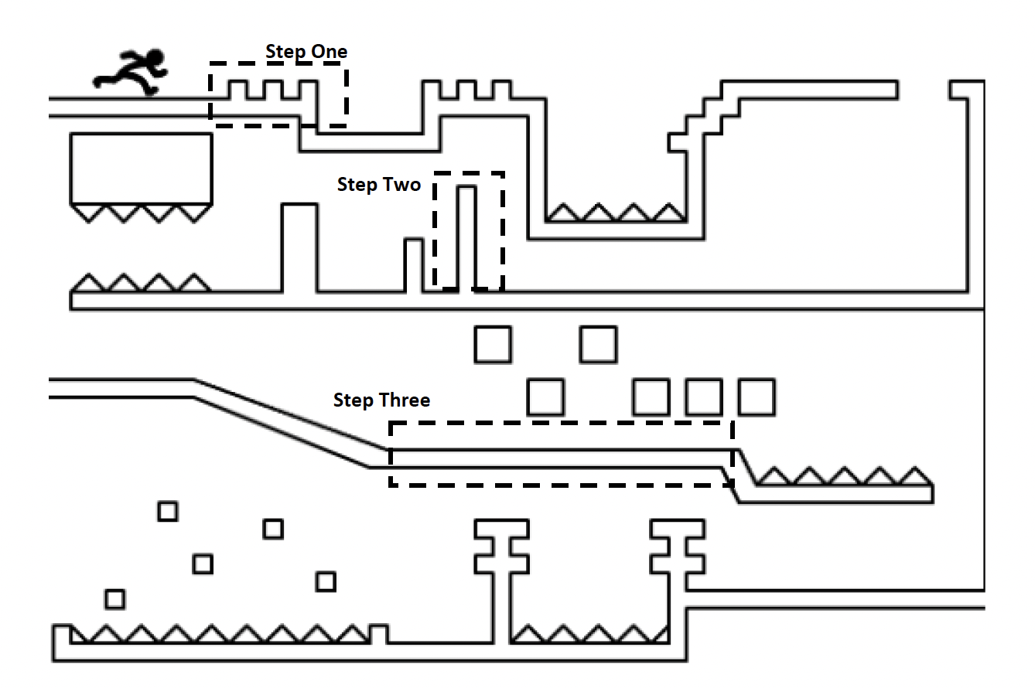

Use the space below for making notes on learning activities you could design for your students given the learning outcome(s) you identified above.

|  |
| --- |
|  |

## Putting It All Together

The first section can be a bit different from a regular section for a number of reasons. However, one of the main things that is different is the component of introductions and ice breakers. Although they can be annoying or awkward, icebreakers are an important method of getting to know your students and getting them to know each other. In order to really have community in the classroom, your students need to feel comfortable with you and each other.

The type of icebreakers you use to start class set an expectation for how much the students are going to have to interact with each other. Additionally, the way you introduce yourself and have the students introduce themselves also sets a precedent for the semester. For information on introductions and other things to think about before your first section look in your New TA Guide (pg. 5-10).

After looking at the New TA Guide, fill out the chart below according to the learning outcomes, assessment, and learning activity you decided on earlier.

### First Section Outline

|  |  |
| --- | --- |
| **Introductions and Icebreaker Time:**    *\*Make sure you are greeting students as they arrive. Class starts when you see the first student.* |  |
| **Learning Activity Time:** |  |
| **Assessment Time:** |  |
| **Reflection Time:** |  |

# 

# Small Group Session: Difficult Classroom Situations

2:45pm - 4:00pm CDT (7/7)

You and your breakout group will be assigned one of the six themes below. Each theme has at least one scenario accompanying it. Consider the classroom situation(s) for your theme: What would you do in these situations? Can you think of anything that might prevent the scenario in the first place? Each breakout group will report back to the whole cohort on one scenario (if your theme has more than one, choose just one). What was interesting, productive, confusing, or challenging about this scenario?

## Theme 1: Grading

|  |  |  |
| --- | --- | --- |
| **Description** | **What could prevent this?** | **What can you do in the moment?** |
| 1. Students will likely challenge your grading. Sometimes this is because you DID overlook something, but often it’s because students think they can boost their grade simply by making a complaint. |  |  |

## Theme 2: Team Teaching

|  |  |  |
| --- | --- | --- |
| **Description** | **What could prevent this?** | **What can you do in the moment?** |
| 2. As a TA, you teach something in an erroneous or misleading way that negatively impacts students’ grades on quizzes. The students get upset.  3. You get sick at the last minute!  4. Your lead instructor doesn’t provide much guidance and you don’t know how to advocate for yourself about your work. |  |  |

## Theme 3: Identities and Sensitive Topics

|  |  |  |
| --- | --- | --- |
| **Description** | **What could prevent this?** | **What can you do in the moment?** |
| 5. A student is using offensive or insensitive language or being combative during a class discussion or activity. |  |  |

## Theme 4: Students of Concern and Mental Health

|  |  |  |
| --- | --- | --- |
| **Description** | **What could prevent this?** | **What can you do in the moment?** |
| 6. You are reviewing class participation and attendance and realize that a student has missed several meetings. You are concerned that this student’s grade will suffer, and that they have missed a significant amount of material.  7. In one section, a student obliquely refers to a personal issue--not just a predictable stressor like an upcoming exam, but a moment that gives you concern about their safety or fundamental well-being. |  |  |

## 

## Theme 5: Student-TA Relationships

|  |  |  |
| --- | --- | --- |
| **Description** | **What could prevent this?** | **What can you do in the moment?** |
| 8. A student is becoming very clingy and dependent on you as their TA.  9. You receive student evaluations with comments that are personally disparaging.  10. Students in your section challenge your authority and/or knowledge. |  |  |

## Theme 6: Teaching During the Pandemic

|  |  |  |
| --- | --- | --- |
| **Description** | **What could prevent this?** | **What can you do in the moment?** |
| 11. Your section involves in-person group work. Some of your students have expressed concern about COVID-19 and classroom safety and asked other students to share their vaccination status.  12. A student comes to your section without a mask on. |  |  |

* Example Answer Key: <https://go.wisc.edu/838dw2>